Introduction(main section)
Quantum computers have the potential to demonstrate far more powerful computational capabilities than classical computers for certain problems, but they are inherently highly vulnerable to errors. Quantum states can be easily disrupted by even subtle interactions with the external environment (decoherence), and a wide variety of errors can arise due to imperfections in the measurement process, imperfect control signals, and hardware device characteristics. In particular, quantum computation involves many gate operations performed sequentially, allowing small errors to accumulate, and the more the system relies on sensitive quantum effects such as entanglement, the more easily it becomes unstable, significantly affecting the accuracy of results.
For these reasons, a central challenge for today’s quantum computers is not performing quantum operations perfectly, but rather obtaining results that are reliable under realistic conditions where errors are present. Therefore, to run quantum algorithms on real hardware, it is essential to understand the causes and characteristics of errors and to develop strategies to reduce or control them.
Representative approaches to dealing with errors can be broadly divided into two categories. First, there are methods that accept imperfect hardware and improve result quality through post-processing or by refining the execution procedure; this is called Quantum Error Mitigation. Second, there is Quantum Error Correction, which more fundamentally protects logical computation by using additional resources and procedures to detect and correct errors. In this chapter, we first summarize the goals and differences between these two approaches, and then introduce representative error mitigation techniques and error correction techniques in turn.

Quantum error mitigation(subsection 1)
Quantum error mitigation, as its name suggests, is a method for obtaining more plausible results by correcting expectation values (recovering estimates) from execution outcomes contaminated by errors, or by statistically removing error components. Unlike quantum error correction, which constructs codes using additional qubits to detect and correct errors, error mitigation aims to achieve a practically attainable level of accuracy improvement under the constraints of current NISQ hardware (short coherence times, high gate and measurement error rates, and limited numbers of qubits). Most error mitigation techniques have the following characteristics:
- They require little to no additional physical qubits (or only very limited extra qubits).
- Instead, they increase the number of shots, the number of circuit executions, and the cost of post-processing.
- To improve mitigation results, the noise model should not vary significantly, or the calibration required for correction must be reliable.
Subsection treats three representative quantum error mitigation techniques.
- Zero-Noise Extrapolation(QEM subsection 1)
The same circuit is executed multiple times in versions with amplified noise, and after observing how the result changes as a function of noise strength, the trend is used to extrapolate to the value at zero noise.
ZNE consists of two stages:
    - Noise amplification: The original quantum circuit is executed multiple times at different noise rates.
    - Extrapolation: The ideal result is estimated by extrapolating the noisy expectation value results to the zero-noise limit.
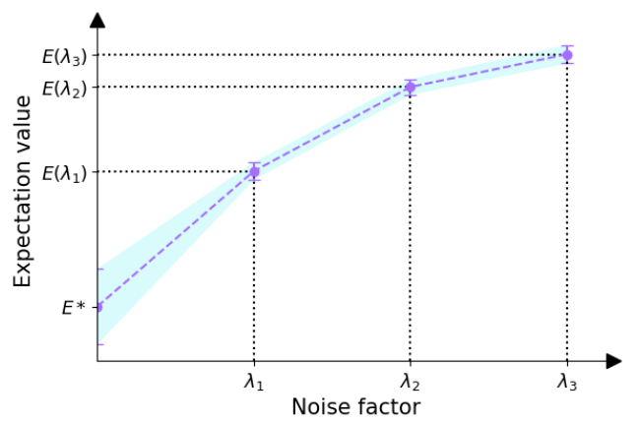
* Ref
(ZNE : Best practices for quantum error mitigation with digital zero-noise extrapolation - Ritajit Majumdar 2023)
Both the noise amplification and extrapolation stages can be implemented in many different ways. Noise is amplified by "digital gate folding," which means that gates are replaced with equivalent sequences of the gate and its inverse. For example, replacing a unitary $U$ with $UU^{†}U$ is called global gate folding and replacing each of $U$₁, $U$₂, $U$₃ to $U$₁$U^{†}₂U$₁, $U$₂$U^{†}₂U$₂, $U$₃$U^{†}₃U$₃
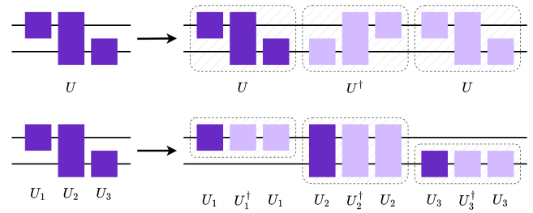
* Ref
(global vs local folding : Best practices for quantum error mitigation with digital zero-noise extrapolation - Ritajit Majumdar 2023)
s
- Probabilistic Error Cancellation(QEM subsection 2)
After modeling the noise channel (how errors are introduced), the circuit is modified so that the noise can be statistically canceled; the modified circuits are executed repeatedly and averaged to estimate the ideal (noise-free) expectation value.
PEC consists of four stages:
    - Noise characterization: Experimentally estimate the noise associated with each gate/channel.
    - Quasi-probability decomposition configuration: Approximate an ideal gate as a linear combination of noisy gates.
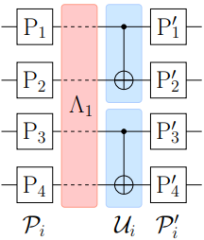
* Ref
(puali twiling : Probabilistic error cancellation with sparse Pauli-Lindblad models on noisy quantum processors - Ewout van den Berg 2023)
    - Random sampling: For each run, sample a circuit modification according to the decomposition and execute it.
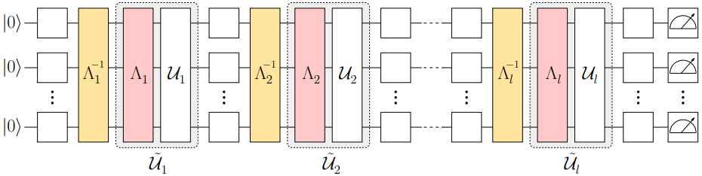
* Ref
(random circuit : Probabilistic error cancellation with sparse Pauli-Lindblad models on noisy quantum processors - Ewout van den Berg 2023)

Recovering expectation value: Multiply each run’s outcome by the corresponding weight and average to obtain a mitigated expectation value.
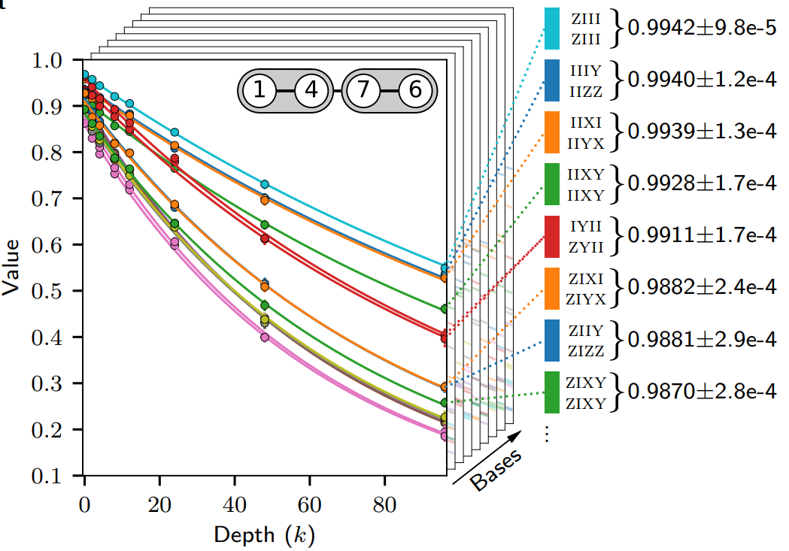
* Ref
(result fidelity : Probabilistic error cancellation with sparse Pauli-Lindblad models on noisy quantum processors - Ewout van den Berg 2023)
- Dynamical Decoupling(QEM subsection 33)
DD mitigates decoherence by inserting carefully designed pulse sequences during idle periods so that slow noise contributions average out over time, reducing error accumulation without directly measuring or correcting the quantum state.
DD consists of two stages :
    - Idle-window identification and pulse insertion: The circuit is analyzed to find idle intervals on qubits, and a DD sequence (e.g., CPMG, XY4, LDD,…) is inserted into those windows while preserving the intended logical computation.
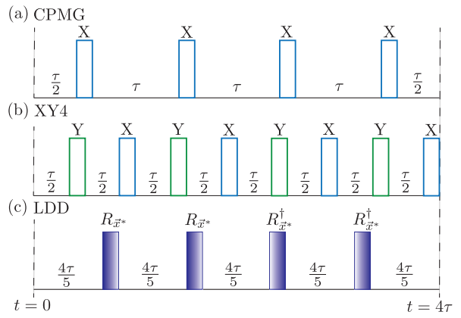
* Ref
(DD sequences : Learning How to Dynamically Decouple - Arefur Rahman 2024)
    - Noise averaging via refocusing: The inserted $π$-pulse pattern repeatedly flips the qubit state so that low-frequency phase noise and unwanted system–environment interactions acquire alternating signs and largely cancel in the time average, yielding improved coherence and more reliable expectation values.
Quantum error correction(subsection 2)
Quantum error correction is a technique that preserves the logical outcome of a computation even when errors occur. The core idea is to redundantly encode a single logical qubit into multiple physical qubits, and while the computation proceeds, periodically measure syndromes that indicate traces of errors to infer “what error occurred,” then apply the corresponding correction operator to cancel the error’s impact..
In the upcoming FTQC era, meaningful algorithms require very deep circuits and many operations. With NISQ-level error rates, errors accumulate and can easily cause the computation to fail, making quantum error correction essential.

Basis of QEC (QEC subsection 1)
In the early days of quantum theory, quantum error correction was thought as impossible.
There are two main arguments to claim that quantum error correction is impossible:
  - No cloning theorem. Errors in classical computers can be corrected by simply repeating the data and applying majority rule.
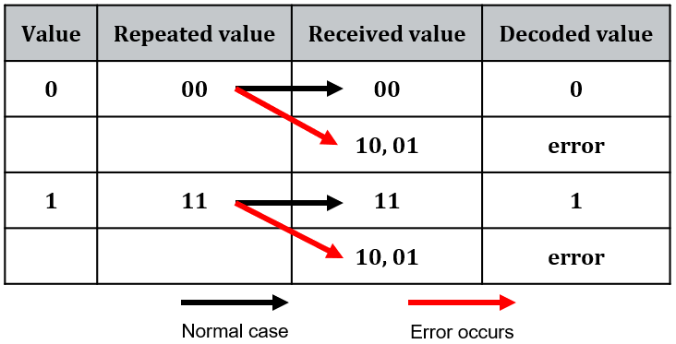
For this action, we should copy the data, that is restricted in quantum information theory by Peter Shor
  - Finite precision control. Quantum information is analog. Problem starts from here. If the analog properties of the information carriers are truly vital for the computation to work, how can we represent the “accurate” value of quantum state? And if, on the other hand, we only need to keep the information from being disturbed by errors above a fixed finite precision, then we have effectively discretized the problem.
The two early seemingly impossible obstacles ended up clarifying exactly what principles a practical quantum error-correction code must be built on.
First, because we cannot restore quantum data by copying the state and applying a classical majority rule, QEC must be able to learn about errors without copying or directly measuring the data qubits. This becomes possible through indirect measurement, also called syndrome measurement. Instead of measuring the logical state stored in the data qubits, we couple the data to ancilla (measurement) qubits so that we measure only parity/stabilizer information. The outcomes are a classical bit string (called syndrome) that indicates whether an error occurred and, to a large extent, what kind of error pattern is consistent with the observation while not revealing the encoded amplitudes themselves.
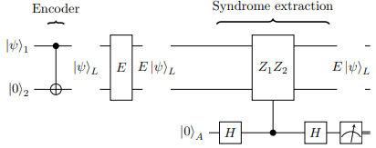
* Ref
(Quantum Error Correction: An Introductory Guide - Joschka Roffe 2019)

Second, although physical noise is fundamentally continuous so that raising the concern of how one could ever correct “arbitrarily small rotations” with imperfect control. QEC resolves this via the discretization of errors. Even when the underlying noise is continuous, repeated stabilizer measurements project the corrupted state onto stabilizer eigenspaces, so the effect of noise becomes equivalent to a discrete set of effective error operators, most commonly taken from the Pauli set {X, Y, Z}. In this sense, QEC converts an analog error process into a digital inference-and-correction problem.
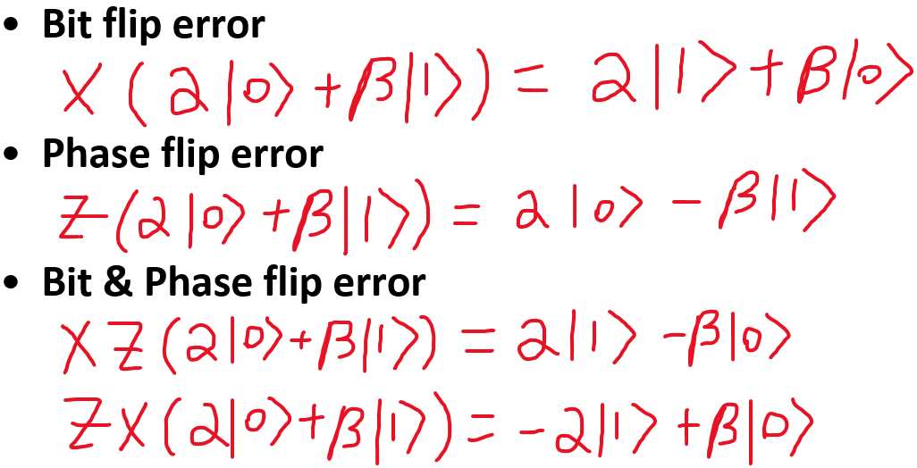
These two principles naturally lead to the stabilizer code framework, which can be viewed as a quantum extension of classical linear codes and parity checks. Most practical QEC codes such as CSS codes, surface codes, and color codes are designed around extracting syndromes via stabilizer/parity checks using ancillas and leveraging the resulting digitized syndrome information so that a decoder can infer and apply an appropriate correction.
Workflow of QEC code(QEC subsection 2)
In this section, we treat the process of QEC code from encoding to applying correction operator. Also, we introduce some information which is needed in each step.
QEC generally operates in the following sequence:
  - Encoding: Distribute and store logical information across multiple physical qubits. There are several codes that can store logical information, and the choice of code determines key trade-offs such as physical-qubit overhead, achievable code distance, stabilizer weight, decoding complexity, and the availability of fault-tolerant logical gates. Different codes therefore come with different advantages and limitations. 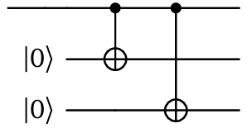
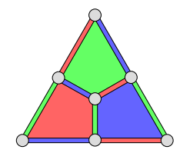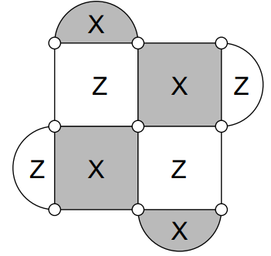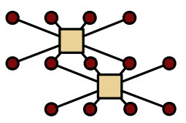
* Ref
(encoding circuit : Quantum Error Correction - Joseph M. Renes 2024)
(color code : Topological Quantum Distillation - H. Bombin 2006)
(surface code : Scalable extraction of error models from the output of error detection circuits - Austin G. Fowler 2014)
(qLDPC code : Flag-Proxy Networks: Overcoming the Architectural, Scheduling and Decoding Obstacles of Quantum LDPC Codes - Suhas Vittal 2024)
  - Syndrome extraction: Repeatedly measure stabilizers using ancilla (measurement) qubits so that the data qubits are not directly measured and the encoded information is not destroyed; a syndrome is the collection of classical measurement outcomes (typically ±1 or 0/1 bits) indicating whether each stabilizer/parity-check is satisfied, and it reveals the presence and location pattern of errors without revealing the logical state itself. In practice, each stabilizer measurement implements a parity-check principle: the ancilla is prepared in a known state (e.g., $∣0⟩$for measuring $Z$-type parity or $∣+⟩$for measuring $X$-type parity), then entangled with a specific set of data qubits via controlled operations (e.g., CNOTs) so that the ancilla accumulates the parity of their Pauli eigenvalues, and finally the ancilla is measured to produce a single syndrome bit—e.g., for a $Z$-type check, applying CNOTs from data qubits (control) to the ancilla (target) maps the parity of data-qubit $Z$ eigenvalues onto the ancilla’s $Z$measurement outcome, while for an $X$-type check the same idea is used in the complementary basis (often by preparing/measuring the ancilla in the $X$basis, equivalently surrounding the CNOT pattern with Hadamards), and repeating these stabilizer measurements over many cycles allows the decoder to track changes in syndrome bits over time and distinguish data errors from measurement noise.
Decoding: Infer the most likely set of errors from the observed syndromes by using the code’s parity-check structure to map syndrome patterns to candidate error configurations, then selecting the configuration that is most probable under an assumed noise model.
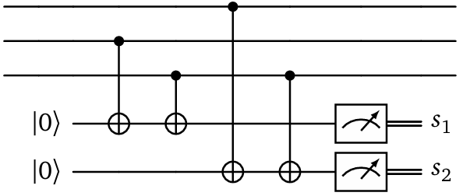
* Ref
(decoding circuit : Quantum Error Correction - Joseph M. Renes 2024)
MWPM (minimum-weight perfect matching) treats detection events (changes in syndrome bits across space–time) as nodes in a graph and connects them with edges weighted by the likelihood/cost of an error chain between them, then finds the minimum-total-weight pairing that best explains the observed syndrome, effectively predicting the most likely error paths and their locations/types.
UF (Union-Find) decoding uses a fast clustering principle: it grows and merges clusters around syndrome defects, expanding them until the defects can be paired/neutralized, which approximates the same “connect defects via likely error chains” idea as MWPM but with near-linear-time operations, producing a correction consistent with the inferred cluster connections.
BP (Belief Propagation) operates on the Tanner graph of the parity-check matrix by iteratively passing probabilistic messages between variable nodes (qubits/errors) and check nodes (stabilizers) to estimate marginal probabilities of different error types on each qubit conditioned on the measured syndromes, then chooses the most likely per-qubit error pattern (often with additional post-processing to enforce syndrome consistency).
NN (Neural-network) decoders learn the syndrome-to-correction mapping from data: given many samples of (syndrome, true error) pairs generated from a noise model or hardware data, a trained model outputs either a correction operator directly or intermediate quantities such as per-qubit error probabilities, leveraging pattern recognition to capture correlations (e.g., biased noise, crosstalk, measurement faults) that can be difficult to encode analytically.
* Ref
(MWPM : Topological quantum memory - Eric Dennis 2001)
(UF : Almost-linear time decoding algorithm for topological codes - Nicolas Delfosse 2017)
(BP : On the iterative decoding of sparse quantum codes - David Poulin 2008)
(NN : Neural Decoder for Topological Codes - Giacomo Torlai 2017)
  - Correction: Apply operations that reverse the inferred errors.
Below figure shows the workflow of the QEC with surface code
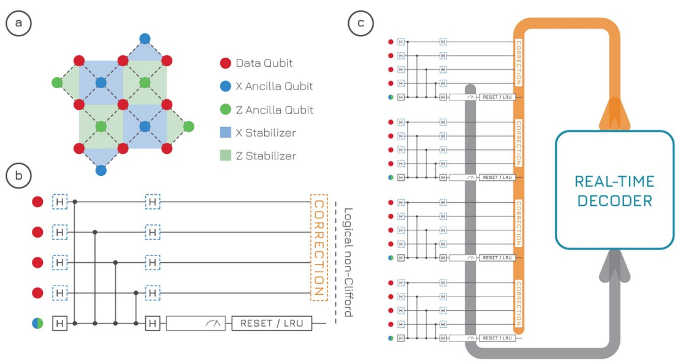
* Ref
(Real-time decoding for fault-tolerant quantum computing: progress, challenges and outlook - 10.1088/2399-1984/aceba6)

